Sets and Relations

What is a set?
To communicate, we sometimes need to agree on the meaning of a certain terms. If the same idea is mentioned several times in a discussion, we often replace it with some new terminology and shorthand notation.
A set is a collection of things, any things, called its elements.
If S is a set and x is an element in S, then we write:
x ϵ S
If x is not an element in S, then we write
x ϵ S
If S is a set and x is an element in S and y is an element in S, then we write:
x,y ϵ S

Describing sets by listing
To describe a set we need to describe its elements in some way.
- The simplest way to describe a set is to explicitly name its elements.
  - e.g.: We can form a set A by collecting three “things”: Cinderella, Tasmania and Tuesday
  - Any set defined this way is denoted by listing its elements, separated by commas, and surrounding the listing with braces:
  - A = {Cinderella, Tasmania, Tuesday}
- Anything can be an element of a set.
  - In particular, a set can be an element of another set.
  - e.g.: B = {x, {x, y}}
    - One element is x and the other element is the set {x,y}
So we can write {x, y} ϵ B

Important features of sets
The only thing that matters about a set:
- What is IN it and what is NOT IN it.
Repeated occurrences of elements don’t matter. Also, the order of the listing doesn’t matter.
- {H,E,L,L,O}, {H,H,H,E,L,L,L,O} and {H,E,L,O} {O,L,H,E} all describe the same set.

Special sets

The set with no elements is called the empty set. The empty set is denoted by {} or more often by the symbol 0 (NB: The 0 should crossed out diagonally, like this →)
- The empty set has no elements, so no matter what thing x denotes, x ϵ 0
- On the other hand, the empty set can be an element of another set.
  - e.g.: 0 ϵ {a, {0, Joe}} or 0 ϵ {0}
- Any set with one element is called a singleton.
  - e.g.: {a} and {Monday} are singletons, but {x,0} is not.

Equality of sets
Two sets are equal if they have the same elements.
- We denote the fact that two sets A and B are equal by writing A = B
- If the sets A and B are not equal, we write A =/= B

Finite and infinite sets
Suppose we start counting the elements of a nonempty set, S, one element per second. If a point of time is reached when all the elements of S have been counted (we might need to have one of our descendants to finish up), then we say that S is finite.
If the counting never stops, then S is an infinite set.
- Examples of infinite sets:
  - Z = {…, -3, -2, -1, 0, 1, 2 ,3, …} – Integers
  - N = {0, 1, 2, 3, …} – Natural numbers
  - N⁺ = {1, 2, 3, …} positive natural numbers = positive integers
  - Q – The set of rational numbers i.e.: any number that can be expressed as m/n for some integers m and n=/=0
  - R – The set of real numbers i.e.: they include all rational numbers and also irrational numbers
  - R⁺ – The set of positive real numbers.

Describing sets by properties: the set builder notation
Describing an infinite set by listing, using …, might sometimes be possible, but even that can be imprecise.
But listing, say rational numbers, can be quite tricky. Instead of listing elements, we can describe a property that the elements of the set satisfy.
If P is a property, then the set S whose elements have property P is denoted by
- S = {x | x has property P}
We read this as
- “S is the set of all x such that x has property P.”
Or, if we also know that all the elements in S come from a larger set A, then we can write
- S = { x ϵ A | x has property P}
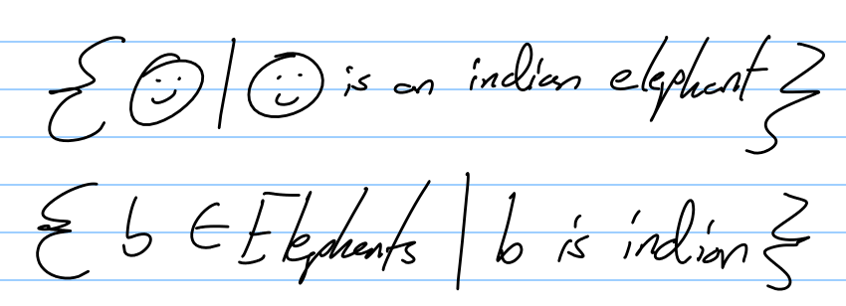

Describing sets by properties: an example
Let Odd be the set of all odd integers. Then we can describe Odd in several ways.
- Odd ={…, -5, -3, -1, 1, 3, 5, …}
- ={x | x is an odd integer}
- ={x ϵ Z | x is odd}
- ={x | x = 2k + 1 for some integer k}
- ={x | x = 2k + 1 for some k ϵ Z }
We can also use more complex expressions on the left hand side of | in the set builder notation:
- Odd = {2k + 1 | k is an integer}
- = {2k + 1 | k ϵ Z}

Describing sets by recursion
A recursive description of a set S consists of three steps:
- Basis step:
  - Specify one or more elements of S.
- Recursive step:
  - Give one or more rules to construct new elements of S from existing elements of S
- Exclusion rule:
  - State that S consists only of the elements that are specified by the basis step, or generated by successive applications of the recursive step.
  - Nothing else is in S.
  - This step is usually assumed rather than stated explicitly.

Describing sets by recursion: examples
- The set N of natural numbers can be defined recursively.
  - Basis step: 0 ϵ N
  - Recursive step: If n ϵ N then n + 1 ϵ N
- The set Odd of odd integers can be defined recursively:
  - Basis step: 813 ϵ Odd
  - Recursive step: If n ϵ Odd then n + 2 ϵ Odd and n - 2 ϵ Odd
- The set A = {3k + 1 | K ϵ N} can be defined recursively:
  - Basis step: 1 ϵ A
  - Recursive step: If x ϵ A then x + 3 ϵ A
- The set F of all formulas of propositional logic can be defined recursively:
  - Basis step: Every propositional variable is in F
  - Recursive step: If p ϵ F and q ϵ F, then (¬p) ϵ F, (p AND q) ϵ F, (p OR q) ϵ F, (p → q) ϵ F and (p ↔ q) ϵ F

Subsets
A set B is a subset of a set A, if every element of B is also an element of A.
- B ⊆ A
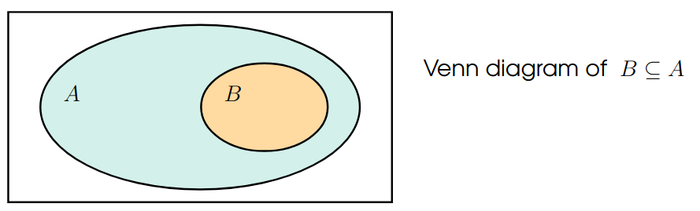
For every element in B, it is also in A.
Examples:
{a,c} ⊆ {a,b,c,d} {0,1,5} ⊆ N N ⊆ Z N ⊆ N
We always have, for every set S:
S ⊆ S ∅ ⊆ S
If B is a subset of A, and there is some element in A that is not in B, then we say that B is a proper subset of A, and can write:
B ⊂ A
In other words:
B ⊂ A if B ⊆ A but B =/= A

How to prove that A ⊆ B or A ⊂ B?
Let A = {x | x is a prime number and 42 <= x <= 51}
B = {x | x = 4k + 3 and k ϵ N}
Show that A ⊆ B
- We need to show that every element in A is also in B.
  - This is a statement in the form ∀ x (“x ∈ A” → “x ∈ B”)
- Take an arbitrary x ϵ A. Then x is a prime number and 42 <= x <= 51
- So either x = 43 or x = 47
  - We can have 43 = 4 * 10 + 3.So the choice of k = 10 shows that 43 ϵ B.
  - We can have 47 = 4 * 11 + 3. So the choice of k = 11 shows that 47 ϵ B as well.
  - Therefore, we have shown A ⊆ B
Show that A ⊂ B
- We have just shown that A ⊆ B. So it remains to find an element x ϵ B such that x /ϵ A. For example, x = 3 is such:
  - As 0 ϵ N and 3 = 4 * 0 + 3, we have 3 ϵ B
  - On the other hand 42 </= 3, so we have 3 /ϵ A

How to prove that A /⊆ B
Let A = {3k + 1 | k ϵ N}
B = {4k + 1 | k ϵ N}
Exercise: show that A /⊆ B, that is A is not a subset of B
- This is a statement of the form ¬∀ x(“x ∈ A” → “x ∈ B”)
- So we need a counter example where x is in A but not in B. For example, x = 4 is such:
  - 4 = 3 * 1 + 1, so k = 1 shows that 4 ϵ A
  - We need to show that 4 ϵ B, that is, there is no k ϵ N such that 4 = 4k + 1.
  - if k = 0, then 4k + 1 = 4 * 1 + 1 = 1 =/= 4
  - and if k >= 1, then 4k + 1 >= 4 * 1 + 1 = 5 > 4
  - So it is not possible to find a k ϵ N such that 4k + 1, and so 4 /ϵ B.
- Therefore, we have shown A /⊆ B

Equality of sets, powersets

How to prove A = B or A =/= B?
A = B means that A and B have the same elements.
- This is a statement in the form ∀ x(“ x ∈ A” ↔ “x ∈ B”)
- A = B iff A ⊆ B and B ⊆ A
- A =/= B iff A /⊆ B or B /⊆ A
So:
- if the task is to show that A = B, we need to show both A ⊆ B and B ⊆ A
- if the task is to show that A =/= B, we either need to find an element in A that is not in B, or to find an element in B that is not in A.

The power set of a set
The set of all subsets of a set S is called the power set of S which we denote by P(S)
so P(S) = { A | A ⊆ S }
e.g.:
- As for every set S, we always have ∅ ⊆ S and S ∈ P(S)
- P({u,v,w})={∅,{u},{v},{w},{u,v},{u,w},{v,w},{u,v,w}}
  - WATCH OUT!{∅}/∈P({u,v,w})
- P({Joe,Tuesday})={∅,{Joe},{Tuesday},{Joe,Tuesday}}
- P(N) ={X | X ⊆ N}.
  - so, say, {453,11,5} ∈ P(N),{81,2} ∈ P(N),∅ ∈ P(N),

